Abstract
In today's competitive business environment, organizations generate a massive amount of sales data across different products, customer segments, regions, and time periods. However, raw transactional data stored in spreadsheets makes it difficult for decision-makers to identify meaningful business trends and performance patterns. This project, Region wise profitability dashboard in power bi, aims to transform raw sales data into interactive visual dashboards that provide valuable business insights. The dashboard analyzes sales, profit, orders, product categories, and regional performance using various power bi visualizations. Interactive filters, calculated fields, and dashboard actions enable users to explore the data efficiently and make informed business decisions. The project helps management monitor sales trends, identify profitable products and regions, understand seasonal patterns, and improve overall business performance through effective data visualization. The dataset includes important columns like Order Date, Sales, Profit, Customer, Region, and Category products. A dashboard is created to visually represent the insights in an easy-to-understand manner. It provides meaningful insights that help management make better decisions. Overall, this project helps to identify the seasonality pattern, sales and profit trends using data-driven analysis.
Objective
The main objective is to design and develop an interactive power bi dashboard that transforms raw superstore sales data into meaningful visual stories, enabling business manager and stakeholders to analyze sales performance and make data-driven decisions.
Other Objectives:
- Analyze profit performance across different regions.
- Identify monthly sales trends.
- Evaluate product performance based on sales and profitability.
- Analyze sales and profit in regional and state contributions.
- Build an executive-friendly dashboard for business decision-making.
- Improve data interpretation using interactive visualizations.
Problem Statement
Superstore retail company generate thousands of sales transactions every day. Although this information is available in spreadsheets, it is difficult to analyze trends, compare performance, and identify business opportunities using static reports. Decision-makers cannot easily determine which products generate maximum revenue, which regions perform better, or how sales change over time. The absence of interactive dashboards limits business analysis and slows decision-making. Therefore, an interactive Tableau dashboard is required to convert raw sales data into meaningful visual insights that support efficient business decisions. The data is fragmented in across sales, finance, and operational system which is difficult to identify the high and low performing region for stakeholders. There is a limited visibility in factors affecting regional profitability such as sales volume, operational costs and discounts. Traditional reports are slower in business decisions and make inefficient resource allocation.
Proposed System
The proposed system develops an interactive power bi dashboard using the Regional sales trend 2023-2024 dataset. The dashboard provides comprehensive visualization of sales performance through multiple dashboards such as Executive Dashboard, Sales Trend Dashboard, Regional Analysis, and Product Analysis. Interactive filters, calculated fields, and dashboard actions enable users to explore data from different perspectives. The system converts raw data into meaningful business insights, allowing management to monitor KPIs, compare performance across different dimensions, identify seasonal trends, and make informed business decisions.
Advantages
- Interactive dashboards improve business analysis.
- Easy identification of sales trends.
- Real-time filtering and drill-down analysis.
- Executive-friendly visualization.
- Better understanding of regional performance.
- Improved product performance analysis.
- Supports faster decision-making.
- Reduces manual reporting effort.
- Professional and visually appealing reports.
Existing System
Currently, the company has lack of centralized system to monitor profitability across various regions. Traditional reports are slower in business decisions and make inefficient resource allocation. This data is fragmented in across sales, finance, and operational system which is difficult to identify the high and low performing region for stakeholders. There is a limited visibility in factors affecting regional profitability such as sales volume, operational costs and discounts.
Disadvantages
- Large datasets are difficult to understand.
- Manual analysis consumes significant time.
- No interactive dashboards.
- Difficult to identify business trends.
- Unable to monitor profit wise performance dynamically.
- Limited support for executive decision-making.
- Higher chances of human error.
Modules Used
- Dataset from Kaggle (Superstore Sales data)
- Columns: Order Date, Country, City, State, Region, Category, Sub-category, Sales and Profit
- Tool used: Power bi Desktop
- Visualization: Charts and Dashboard
Methodology
The project follows a structured methodology to ensure accurate results. First, the dataset is collected from Kaggle. Then, the data is imported into power bi for processing. Key performance indicators(KPI) such as Total sales, Total profit, Profit margin and Total Orders are created. Calculative measures are used to summarize and analyze the data. Charts and visualizations are created for better understanding. A dashboard is designed to display all insights in one place. Filters and slicers are added for user interaction. Finally, the dashboard is tested and finalized for use.
The project includes multiple levels of analysis to gain meaningful insights. Sales trend analysis to identify the sales growth over time. Regional analysis helps in understanding which region has high and low sales. Product analysis is done to compare product across different Category. Profit analysis is conducted to study its impact on sales and growth productivity. These insights help shareholders and management make better decisions. Overall, the analysis provides a clear understanding of business performance.
Conclusion
The Region wise profitability dashboard in power bi successfully demonstrates how Business Intelligence and data visualization techniques can transform raw sales data into meaningful business insights. By integrating multiple interactive dashboards, KPIs, and visual analytics, the project enables users to evaluate sales trends, monitor profitability, analyze regional and product performance, and identify growth opportunities. The use of power bi improves reporting efficiency, enhances decision-making, and provides an executive-friendly platform for exploring business performance. This project highlights the importance of interactive dashboards in helping organizations make timely, informed, and data-driven decisions while improving overall operational performance.
Result
The project produces an interactive power bi dashboard that enables business users to monitor profit performance, compare historical trends, evaluate regional and product performance, identify seasonal patterns, and support strategic business decisions. The dashboard simplifies complex sales data into meaningful visual insights for executives and managers.
Future Improvement
The project can be further improved by adding advanced features. It can be integrated with Power BI for better visualization. Real-time data updates can be implemented. Machine learning models can be added for prediction. Future forecasting can help in future planning. Automation can reduce manual work. Advanced filters and drill-down features can be included. Mobile-friendly dashboards can be developed. More datasets can be integrated for deeper analysis. Predictive analytics can improve accuracy. These improvements will make the system more powerful and efficient.
Output
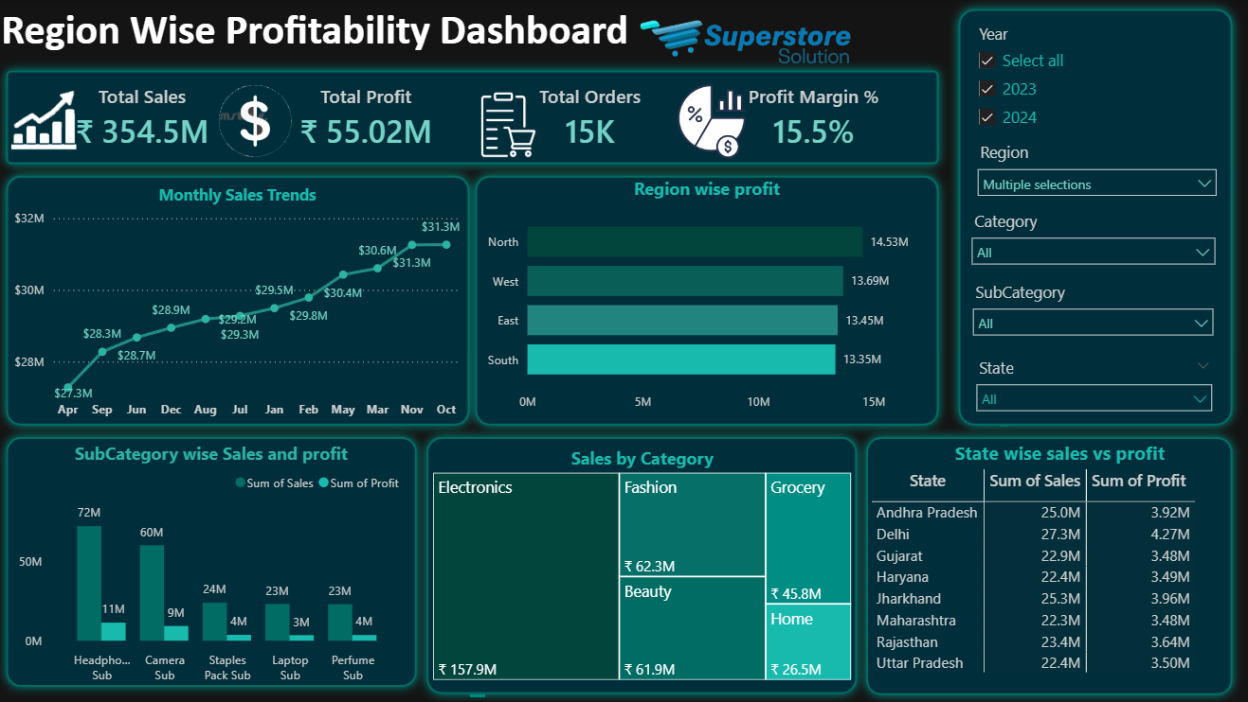
Reference
- Regional Sales Trend Dashboard in Power BI (2023–2024) | Free Dataset | Sales Analytics Project
- Dataset is collected from Regional Sales Trends Dashboard - Google Drive
- Real Time Power BI Project | Power BI Dashboard | Power BI Tutorial | End to End | Insurance Domain
- How to Design Beautiful Background for Dashboard | #tableau #excel #powerbi @Data Tutorials

